**DAILY ONLINE ACTIVITIES SUMMARY**

|  |  |  |  |  |  |  |  |  |
| --- | --- | --- | --- | --- | --- | --- | --- | --- |
| **Date:** | 29-05-2020 | | | | | **Name:** | K S Prajwal | |
| **Sem & Sec** | Vi A sec | | | | | **USN:** | 4AL18CS032 | |
| **Online Test Summary** | | | | | | | | |
| **Subject** | | Operating system | | | | | | |
| **Max. Marks** | | 30 | | **Score** | | | 28 | |
| **Certification Course Summary** | | | | | | | | |
| **Course** | Computer Vision Essentials | | | | | | | |
| **Certificate Provider** | | | Greatlearning.in | | **Duration** | | | **3 hr** |
| **Coding Challenges** | | | | | | | | |
| **Problem Statement:**  1. Write a Java program to Find size of the largest ‘+’ formed by all ones in a binary matrix  2. Write a C Program to generate first N Armstrong Numbers | | | | | | | | |
| **Status:** completed | | | | | | | | |
| **Uploaded the report in Github** | | | | | yes | | | |
| **If yes Repository name** | | | | | <https://github.com/alvas-education-foundation/KS_Prajwal> | | | |
| **Uploaded the report in slack** | | | | | yes | | | |

Online Test Details: (Attach the snapshot and briefly write the report for the same)

Certification Course Details: (Attach the snapshot and briefly write the report for the same)

Coding Challenges Details: (Attach the snapshot and briefly write the report for the same)

**Online Test Details:**

1. **OS:** The online test was from module 2 which was about Multi-threaded Programming. There were 30 questions and the duration was 45 minutes. The questions were optimal and were easy. The score that I got in the test is 28/30.

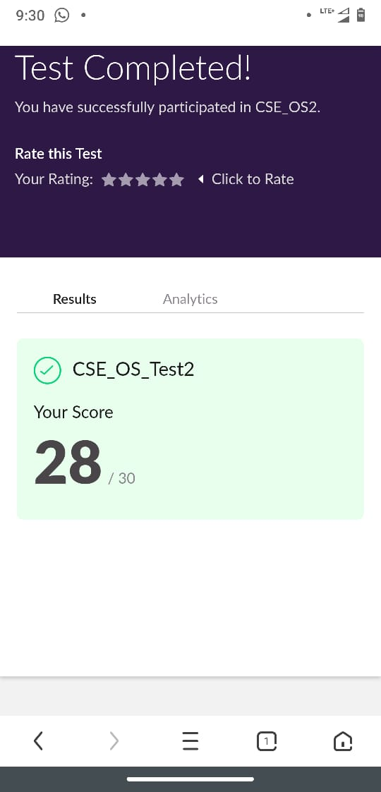

Snapshot of certification course:

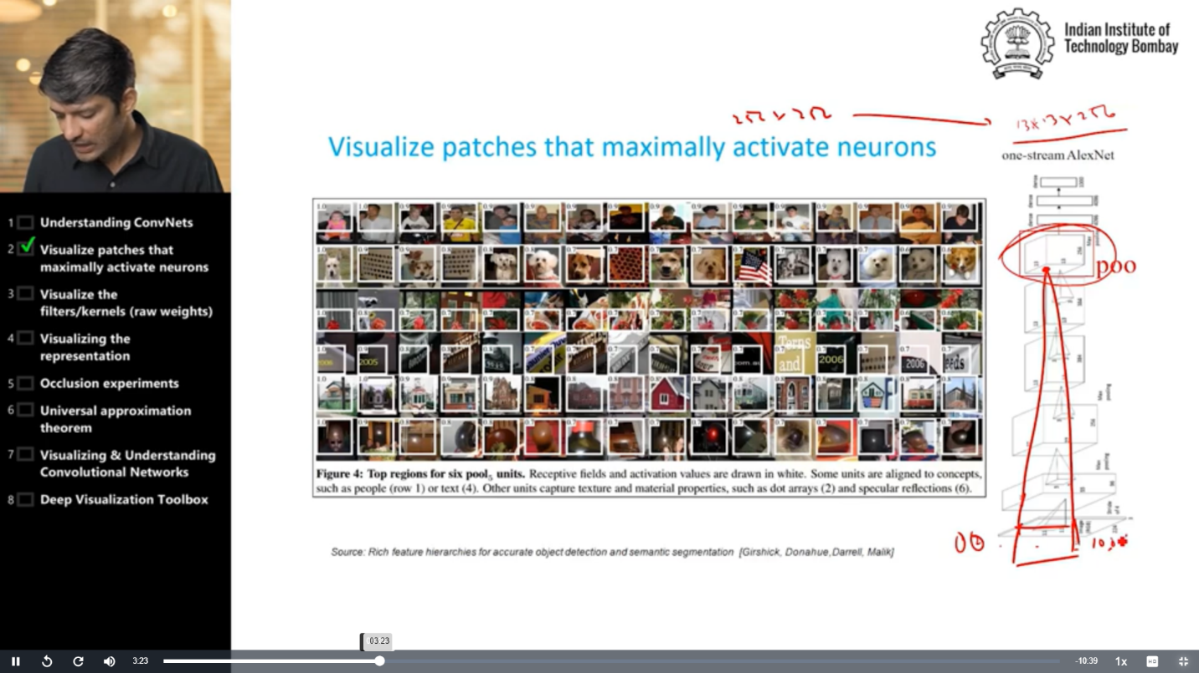

It was about Visualization, run package, occlusion experiment and they showed the demo on T-SNE.

**Online coding:**

Problem 1: (using java) Write a Java program to Find size of the largest ‘+’ formed by all ones in a binary matrix

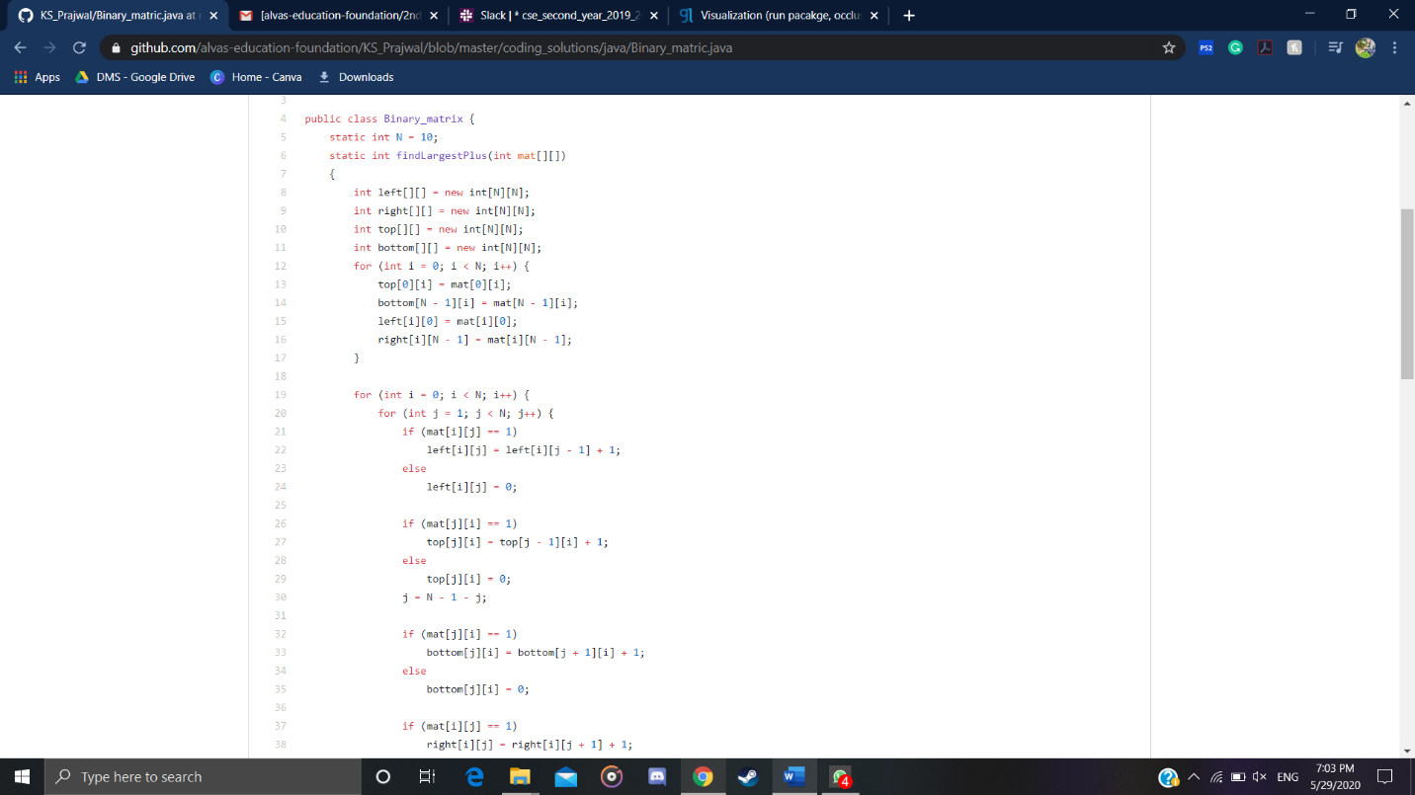

Problem 2: (Using c language) Write a C Program to generate first N Armstrong Numbers

